**CSA1086 - Software Engineering**

GitHub File Pushing

STEP 1: Type git init

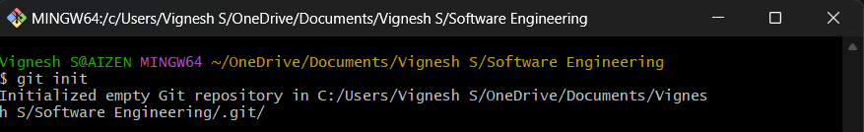

STEP 2: Create a repo in git hub

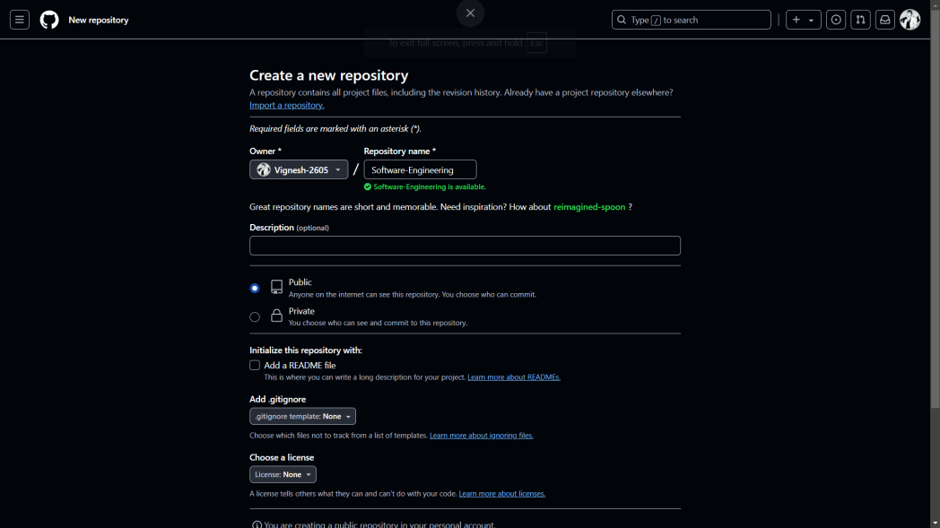

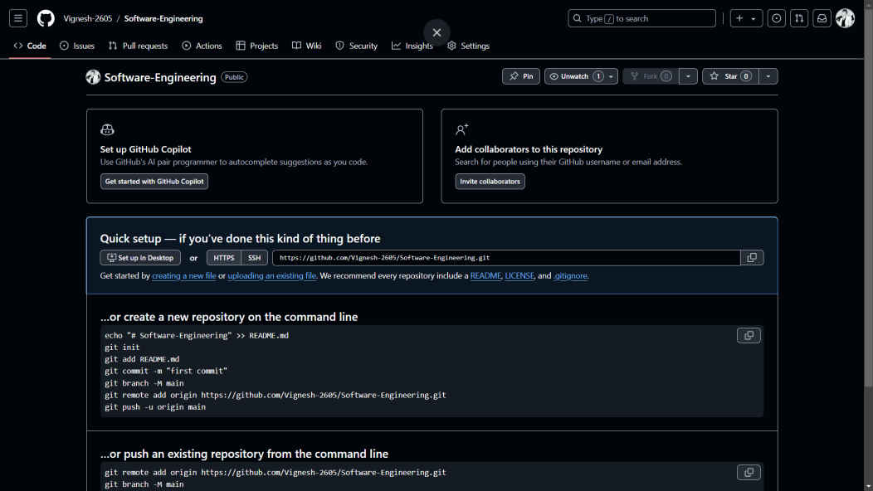

STEP 3: type git status

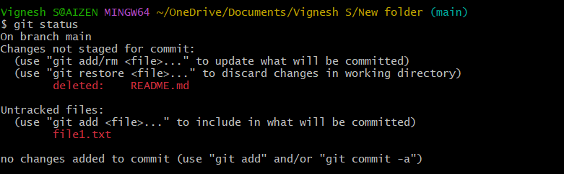

STEP 4: Input content into the text file

Screenshot 2024-12-04 133238

STEP 5: Add the file to ready status

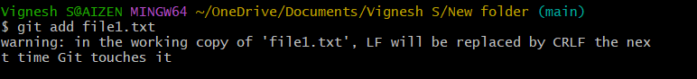

STEP 6: Commit the status

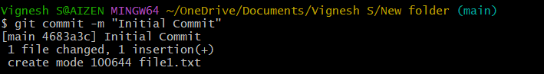

STEP 6: Check the origin

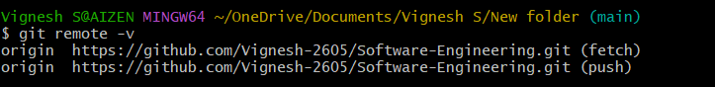

STEP 7: Push the file into main branch

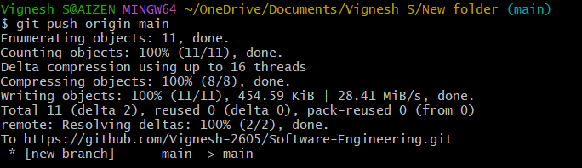

STEP 8: Check your repo for the files

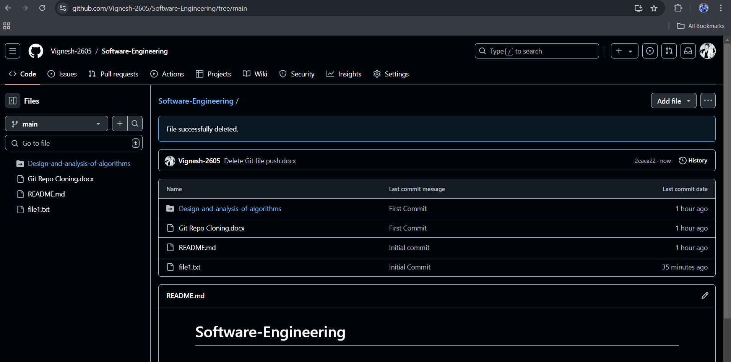

By:

S.Vignesh

192325002